Saga Design Pattern

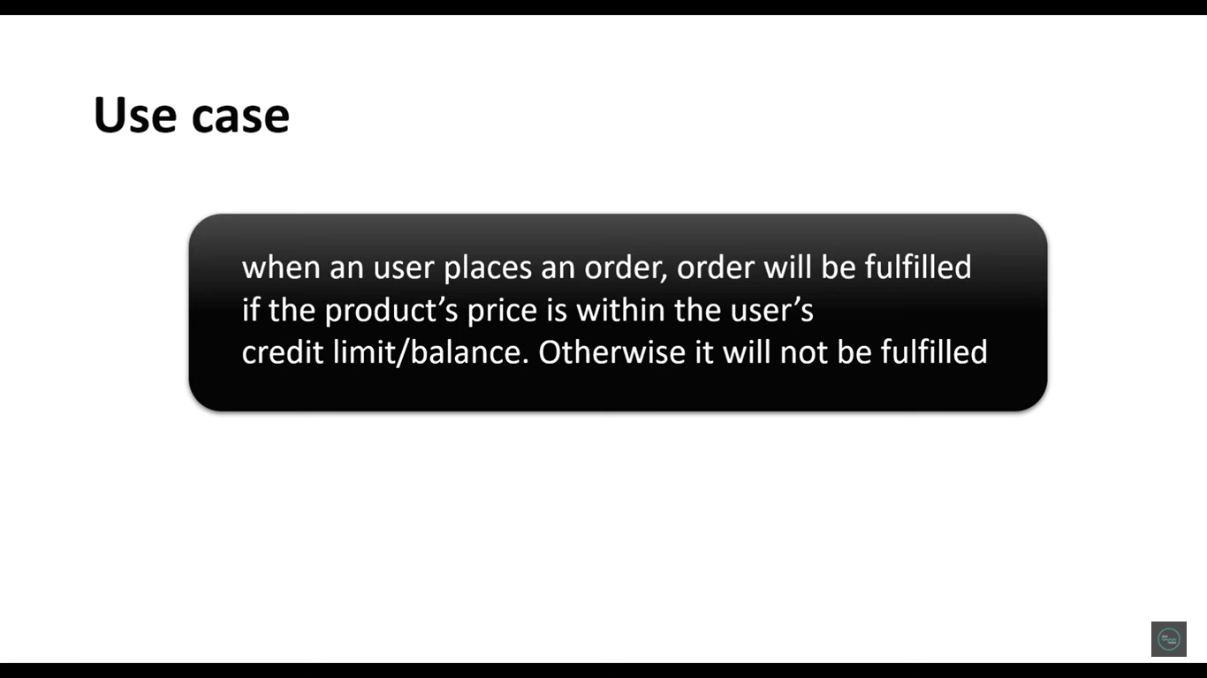

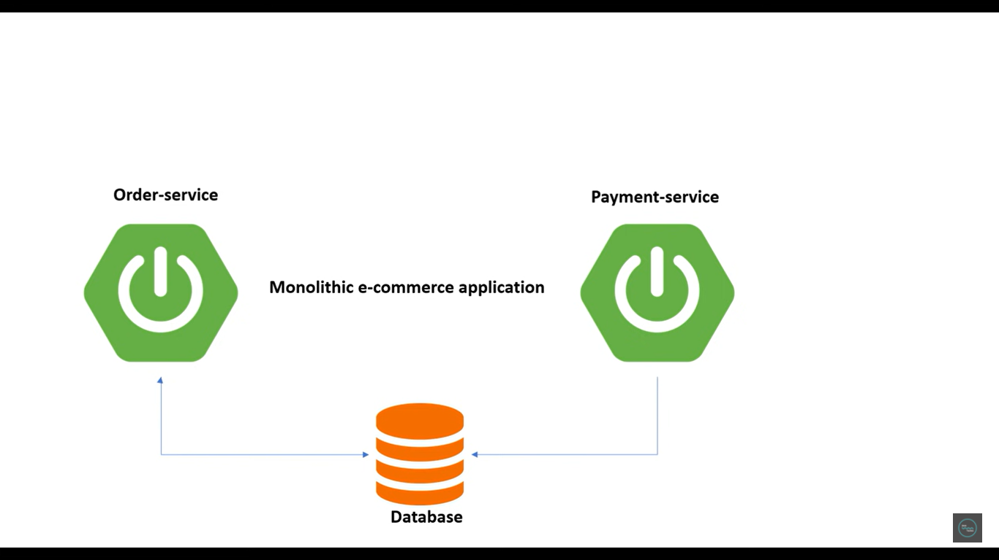

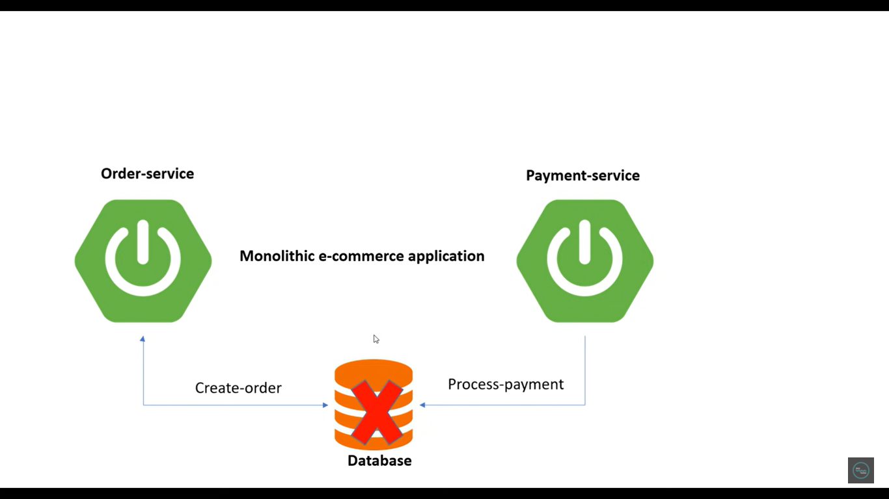

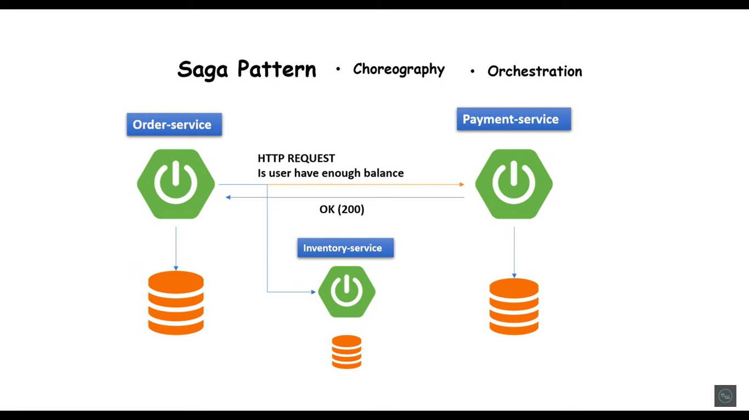

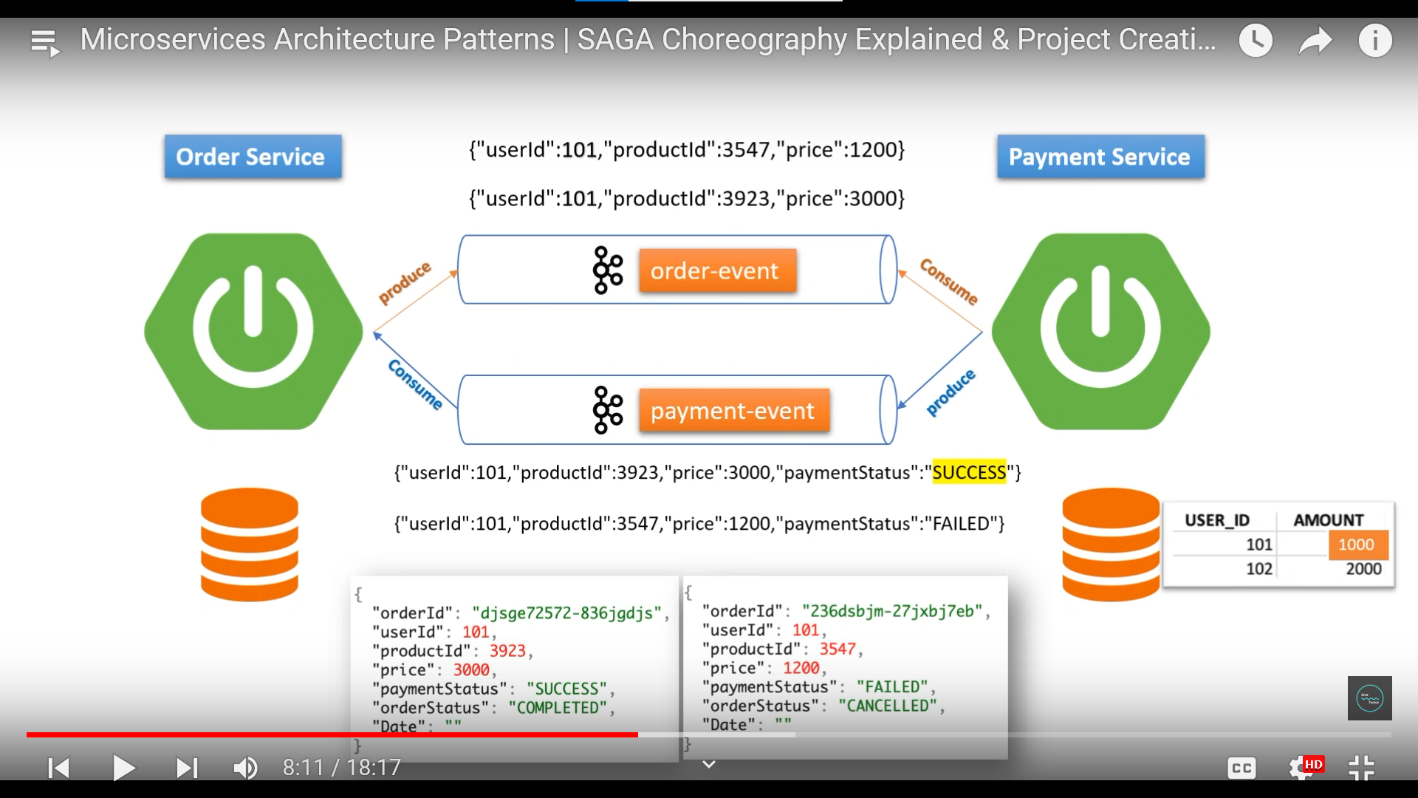

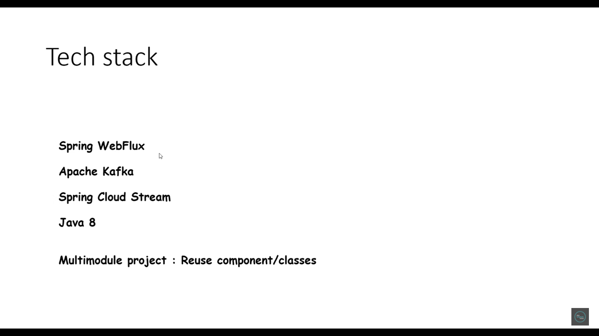

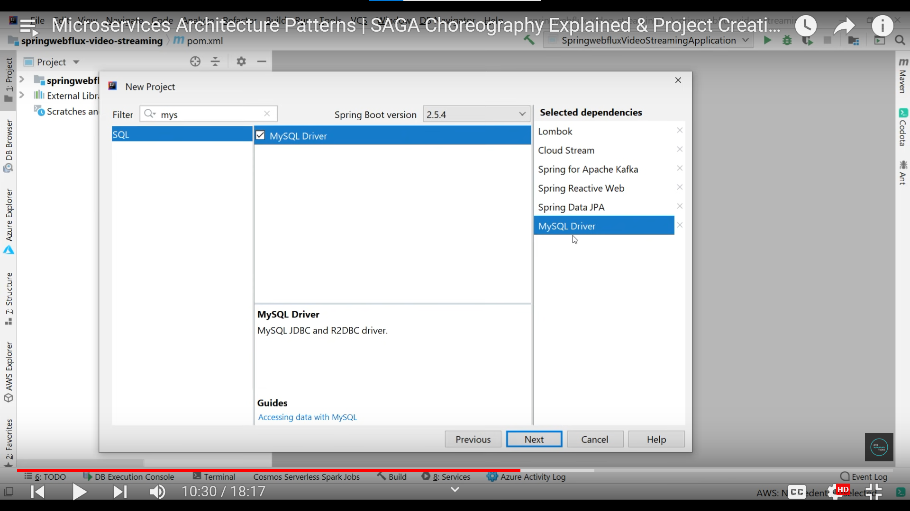

Apache kafka and zookeeper installation:

<https://www.javatpoint.com/installation-of-apache-kafka>

<https://www.youtube.com/watch?v=aOen1-pQLZg&list=PLVz2XdJiJQxw1H3JVhclHc__WYDaiS1uL>

https://github.com/Java-Techie-jt/saga-choreography-example

